1. **Technical Merit and Need**

**Goals, objectives, technological or scientific knowledge advancement, and innovation in the proposed project:**

Conflicting public policy directives to limit forest fires, create renewable energy, and provide clean air are running headlong into the impacts of prolonged drought, and the economic realities of large-scale bioenergy production facilities. To untie this Gordian knot, California needs a way to make affordable renewable energy from forest biomass, which would monetize forest fire remediation waste and thus enable more widespread thinning. Doing so will also increase the amount of water available for hydrological energy use, agriculture, and other purposes.

This project presents a potential solution, by designing, engineering, and manufacturing a fully functional prototype 150kw modular biomass gasification system. It will convert forest fire remediation waste of various species into on demand renewable energy while complying with applicable emissions standards. Importantly, it will be designed to operate at a scale sufficiently large to process enough material as to make an impact on forest fuel load, while being mobile and modular to be able to be transported to fuel sources. Finally, the system will be engineered with an end goal of a Levelized Cost of Energy (LCOE) sufficient to stimulate market response.

More than just hardware, this project will also provide a multidisciplinary, comprehensive overview of a range of societal benefits. It will summarize the avoided emissions from gasifying biomass instead of burning it. It will highlight the potential of this on demand renewable energy to address peak demand and capacity constraints. Finally, it will explore the scaling impact monetizing the waste and thus increasing scope of thinning, and calculate potential water savings, drought alleviation, and increased hydro capacity through increased forest thinning.

**Technological advancement and breakthroughs:**

This project will create an affordable modular, mobile generator that can be sited closer to the feedstock, reducing the number of miles the feedstock needs to be transported, increasing the economic value of the energy generated.

This transformative innovation will be accomplished through the refinement of a compact and integrated biomass thermal conversion system combining innovative reactor design, emissions controls, multi-stage thermal recycling architecture, and high capacity factor/usability enabled by an automated microcontroller system. An emissions system will be designed to meet California’s exacting emissions requirements, using advanced mixture controls, centrifugal precipitation and inline catalysts, and it will all be housed within a standard shipping container form factor to enable simplified transportation.

This, in turn, will create new economies of scale to enable an LCOE for biomass energy sufficient to stimulate subscription to the 50MW biomass set aside in the ReMAT program established by SB1122.

Based on historical data, it is estimated that gasification for energy instead of burning for disposal will reduce GHG emissions more than 90%. Further, by monetizing what is now free and useless, the enabled increased thinning will aid in reducing the risk of catastrophic wildfire. Reduced forest load will also contribute to additional water and hydro power resources.

The result will be a market driven solution that increases use of forest biomass to create on demand renewable energy. Due to the mobile nature of these devices, grid managers may also be able to address peak shaving and local capacity issues through dispatchable renewable energy.

**Current status of the relevant technology:**

Currently there are few (if any) modular biomass gasifiers at the right price and size to enable economical energy production and biomass utilization in California, while also meeting applicable air quality standards and achieving an LCOE equal to or less than the SB1122 ReMAT price. While the principals of gasification are generally well understood, the equally known challenges to its utilization have not been solved at the scale and price point required to impact the market for California.

That’s not to say low cost systems don’t exist. For the last six years APL has been focused exclusively on building high performance, low cost gasifiers. They are currently at work serving off grid energy needs in the developing world, and most recently the Feed In Tariff market in Italy. They are not yet at work in California, due to the costs of meeting emissions standards.

**The need for EPIC funding:**

California air quality emissions standards present a significant barrier to modular gasification. While a project might make financial sense once built, there’s simply too much R&D required over too many subsystems, relative to other existing markets, to warrant the investment time and resource risk. This circumstance is exacerbated by the relatively low ReMAT of $124Mwh—there’s too little margin to absorb the work of system design. Conversely, if sufficiently resourced those technical challenges will be easy to overcome.

This project will enable evaluation and re-design of various designs at a scale appropriate to considered analysis. Then, expert policy and market analysts will review the data from the testing to better understand the value streams and potential markets.

**Discuss the degree to which the proposed work is technically feasible and achievable:**

The solutions required to achieve project goals are well known and elaborated-much of the work under this project would entail scaling up of existing models and technologies.

The project team has already built a fully operational ‘alpha’ unit prototype of this technology, more than 600 operating gasifiers in the last six years, and has earned several US and international patents for innovative work in the field. Given the above, there are no known technological barriers to project success.

**Measurement and verification plan for energy savings and other benefits:**

Third party emissions testing and compliance regimes will be managed by the relevant regulatory body, the Placer County Air Pollution Control District. This information will be aggregated with project costs from Sierra Pacific Industries and All Power Labs and then provided to the Renewable and Appropriate Energy Laboratory and Center for Forestry at UC Berkeley for analysis.

RAEL will provide comprehensive summaries of LCOE generated, system uptime and capacity factors. These will be reviewed for impact with broader CEC goals regarding renewable energy production, resource adequacy, and peak load reduction. Avoided emissions and GHG will be calculated and summarized.

The Center for Forestry will determine how much forest waste the systems can process into electricity affordably, which can then be used to project scaling. The potential for char waste in industry and agriculture will be calculated. Additionally, hydrological resource impacts will be calculated and projected to understand scaling implications and scope.

1. **Technical Approach**

**Technique and approach: Gasifier and Filtration**

To create a successful modular biomass gasification system, a series of interrelated components will be correctly sized to a 20’ shipping container. This particular form factor is chosen as it combines the best compromise between scale (ability to generate power and consume forest waste) and mobility. It is assumed that multiple units can be linked together to scale energy production/waste disposal as needed.

The most important components for this project will be the reactor, which governs gas production, and the gas filtration system between the reactor and the internal combustion engine. The extent state of design, technical requirements and proposed solutions for each are described in some detail below.

Tar management is the Achilles heel of affordable gasification, and has long been the main barrier that prevents gasification from becoming meaningful in practice, and scaling beyond serial, high dollar demonstration projects. This is because tars not converted in the reactor, or removed via downstream filtering, will quickly destroy an engine.

Common downdraft reactors combine the tar gas flow and char solids together in the same fixed bed. This gas and solid mixing creates a fundamental conflict between the process stages. The high temperatures achieved by tar combustion are immediately moderated by the combusted gases reacting with charcoal starting the exothermic reduction reactions. With combustion and cracking surrounded by char solids, it is inevitable the temperature lowering reduction reactions are always working against the high temperatures and residence time needed for full tar cracking.

Under this project, APL will scale up and revise a patented system that has made significant progress on the tar problem, through a multi-stage heat recovery and recirculation system that also allows better segregation of various thermal processes. All waste heat from both the outgoing syngas, and exhaust from the engine, will be returned via heat exchangers to do useful process work in the gasifier. Both the incoming air and the incoming fuel to the gasifier will be aggressively preheated before reaching the main hearth. (See the chart below for the flows and heat exchange relationships.)

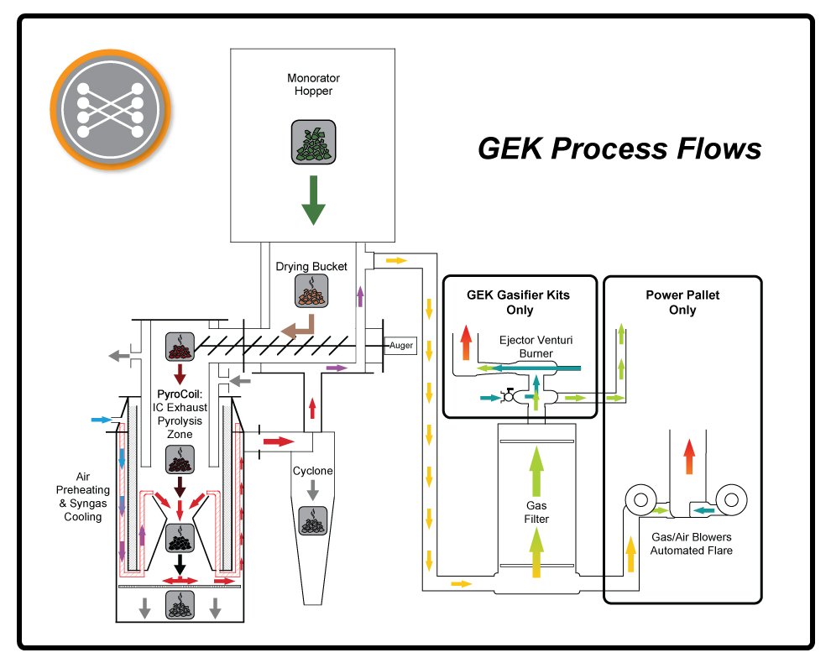

By using the IC exhaust heat to externally drive pyrolysis, pyrolysis temperatures can be held under 600C, and optimized for simpler tars types, which are easier to crack during the combustion stage. These factors will enable an almost doubling of traditional moisture tolerance, from 15% to 30%.

The current APL reactor design will be further refined under this grant through development of a novel swirl hearth that achieves full tar cracking in the reactor, while running on common forestry byproduct chipped/shredded fuels, without post processing screening. The design uses the advanced strategies of full zone separation, forced tar circulation to the nozzles, and an internal swirl combustion annulus to decouple tar cracking from its dependence on fuel void space.

The resulting reactor will be a huge large step towards the “holy grail” of fully fuel agnostic reactor. It will be a sufficient leap to enable the direct running of mixed size and mineral composition forestry byproducts; and do so without pelletizing or briquetting preprocessing steps and their associated machinery.

**Technique and approach: Filtration**

Once the gasses are produced, they will proceed through a filtration system designed to capture both large composites of hydrocarbons and well as microscopic aerosols. The project will develop a unique multi-stage centrifugal mixer and separator that will purpose coalesce and remove the aerosols before final particulate filtration. This system builds on the prior art of industrial mist collectors, and reconfigures their usual architecture to handle the sticky nature of tar aerosols. (See Figure 1 below for a concept drawing of the solution, currently under a provisional patent application).

Fig1-RotaryFilterSideView.pdf

The proposed solution removes the majority of the tar aerosols with media-less centrifugal sections, in a tightly stack arrangement. Flows are accelerated and thrown outward to a vessel wall, then scavenged back to the center for another acceleration and impingement with the vessel. During these passes, rotor edges and internal vanes are placed to create turbulence (an aid to coalescing phenomena) and direct scavenging of the condensed liquids. The condensate flows to temporary catchment bins, from where it is periodically reinjected back into the gasifier via an eductor system.

Once the gas has been processed through the internal combustion engine, the exhaust will be passed over twin catalyst beds, with pre-passage oxygenation, to further clean the emissions to meet applicable standards.

**Technique and approach: Balance of System**

The above highlights the overall approach to managing the redesign of the combustion and filtration processes. However, all aspects of the project will need to be reviewed and adopted to the new requirements. Some of the specific tasks include, but are not limited to:

* Genset. Previously operated on dual fuel diesel/syngas mixture, this new unit will explore syngas only operations.
* Pre-ignition flaring. While heating up to correct temperature, produced gas from the reactor is flared off. This new design will need to incorporate flare gas recycling or enhanced ignition to ensure meeting lower emissions targets.
* Internal/External Fuel Enclosure. Previously designed to operate on corn cobs, modification to operate on the form factor of wood chips. As fuel moves from a large, open air hopper to the reactor chamber, a positive pressure dual air lock system must be created to maintain proper gas ratios and temperatures throughout the system.
* Grid tie. Previous unit ran off grid, new design will incorporate utility grade interconnection hardware.
* Heat mining and recycling. As outlined above in the patented process of the Power Pallet, this project will need to migrate heat from and to various locations, albeit over much larger distances.

**Technique and approach: Data collection**

Following design engineering and preliminary testing in house, APL will field deploy the Powertainer and conduct extended testing for energy production and emissions. The fuel used will be processed and supplied by Sierra Pacific Industries, from forest fire remediation material that would otherwise have been burned. The unit will be interconnected to the PG&E grid per standard interconnection rules, as a net-metered addition to the Place County Water Authority site. Once operational, continuous monitoring for various emissions (CO, NOx) will take place. The Placer County Air Pollution Control District will be responsible for emissions testing and certification for PM2.5, PM10, VOx, and Methane.

The data will be logged onsite, and then provided to all appropriate project stakeholders in raw form by the independent monitoring contractor chosen by Placer County Air Pollution Control District.

A note regarding the scale of the testing unit: gas composition, flow rates, and flow dynamics are highly dependent on the interactions between the physical characteristics of the feedstock and the geometry of the hearth and reduction zone, and the draw from the engine. This makes it impossible to accurately model final emissions results and dynamics for a full size unit at pilot scale. Accordingly, this project will conduct emissions testing on the full size unit.

**Technique and approach: Analysis**

Prior to and following testing, UC Berkeley researchers will conduct analysis and assessment. Utilizing utility dispatch models (PLEXOS), they will determine the economic value of the biomass energy, including the value of the kW and kWh at the nodal level. Various scenarios will be modeled to explore the impact of penetration levels on Resource Adequacy/capacity requirements. Locations where Powertainers can be located to address local capacity deficiencies will be mapped.

A Life Cycle Assessment of varying feed stocks and their emissions under current practice will be conducted. This will include those fuels that would otherwise be burned, with a focus on avoided GHG emissions. The ability to monetize both fuels and avoided emissions will be calculated.

Based on the results, policy recommendations related to on demand renewable energy sourced from biomass--addressing areas such as capacity markets and payments, reliability and intermittent resource smoothing and shaping, biomass sourcing and logistics, localized pricing and cost variability, etc--will be developed and published. All analytical work will be conducted with an eye toward California's existing renewable policy goals and reliability requirements.

**Task execution and coordination:**

APL’s internal engineering/fabrication teams will manage design and construction tasks. Regular meetings will take place between APL and partners to developing timelines and milestones and deliverables.

APL will facilitate the sharing of information between subcontractors, to ensure maximum efficiency and synergy between groups. Weekly or as needed meetings will take place between relevant stakeholders for the duration of the grant period.

**Factors critical for success, in addition to risks, barriers, and limitations:**

Success for this project will also be determined by whether or not it is able to meet avoided LCOE while making energy on demand from forest waste and complying with applicable air quality standards. The most critical factors for the project therefore are the successful scaling of the reactor systems, and the redesign of the filtration systems. Sufficient gas must be made, and of sufficient quality for the engine to operate efficiently.

APL will prioritize the design, engineering, and prototyping of the reactor design and emissions systems at the beginning of grant cycle. This will provide adequate lead-time for multiple iterations of prototypes to be cured, shipped, tested, and optimized without compromising the overall development schedule.

**How the knowledge gained, experimental results, and lessons learned will be made available to the public and key decision-makers.**

Energy produced, emissions made and avoided, financial impacts, and policy implications will be surveyed by the Renewable Energy Laboratory and Center for Forestry of the University of California, Berkeley, which will each publish between one and three independent reports or journal publications with key findings of relevance for energy policy makers, decision makers, system operators, and academia.

Additionally, APL will organize tours for relevant stakeholders, and publish plans, processes, and results in an online wiki, available at www.allpowerlabs.com

**Use of specific renewable resources available in the surrounding regions:**

The project will utilize forest biomass from the Sierra Nevada region of PG&E’s service territory, in Placer County. The project will utilize forest ‘slash’ - biomass that is harvested but is unfit for commercial lumber - as well as thinnings for mitigating catastrophic wildfire. Currently the potential energy of that biomass is wasted, as it is burned in open log landings.

1. **Impacts and Benefits to California Ratepayers**

**Ratepayer Benefits:**

California ratepayers will benefit by increased electrical system reliability, lowered costs, increased safety, and by providing a way to eliminate existing barriers to achieve the state's energy goals.

Greater Reliability: The project will provide mobile, on-demand, non-weather dependent, renewable energy. The generator can be used to provide local capacity in hard to serve areas, while reducing peak demand.

By increasing the economic value of fire remediation efforts, the project creates the potential for lower biomass load in forests and thus increased availability of water for hydrological energy production, agriculture, industry and residential use. A growing body of work suggests that a single acre thinned 18% will yield between .1-.4 acre feet additional water annually for seven years--a significant return on an activity paid for by energy production. By extrapolation, an additional 1,000,000 acres thinned could create as much as 400,000 acre feet of additional runoff, or almost 10% of the combined annual discharge of the Shasta, Oroville and Folsom Reservoirs in 2013[1].

**Diagram: Forest Thinning Impacts on Increasing Available Water**

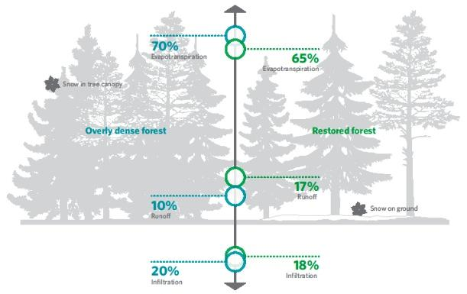

Lower Cost: This project will prove that modular, mobile biomass gasifiers utilizing forest slash feedstock can produce energy at or below the avoided cost of energy.

Increased Safety: By creating demand for forest thinnings, the project will create an economic driver to support forest thinning, reducing the risk of wildfire and damage/destruction of CA’s IOU owned transmission lines. The project will also reduced tree trimming costs: IOUs spend millions of dollars a year on trimming tree lines around their transmission lines. By creating a market for tree thinnings, this will reduce the amount that will need to be paid by IOUs, and ratepayers.

**Quantitative benefits:**

The project will solve the technical barriers to successfully demonstrate the ability and potential for on demand biomass energy to provide peak load reduction, at a price point that is equal to or less than the current REMAT rate from SB1122. This will likely lead to the creation a functioning non-subsidized market for forest remediation waste. Specific benefits summarized below:

Energy:

The below table reflects a quantitative estimate of benefits to California IOU electricity ratepayers if the completed unit were run for one full year at a 60% capacity factor. The estimates are based on a combination of current market data, APL’s internal research, and public documents. The below estimates are conservative, providing low downside risk.

|  |  |
| --- | --- |
| **Benefit** | **Estimate** |
| Annual Electricity Savings | 788,400kWh[2] |
| Peak Load Reduction | 150kW[3] |
| Energy Cost Reductions | $97,761[4] |
| Water Reductions | 68,780 gallons of water from energy savings[5] |

GHG Emissions Reductions:

Based on data from the Placer County Air Quality Control District, it is estimated that emission reductions from pile burning of Sierra Nevada tree species will exceed 90%.

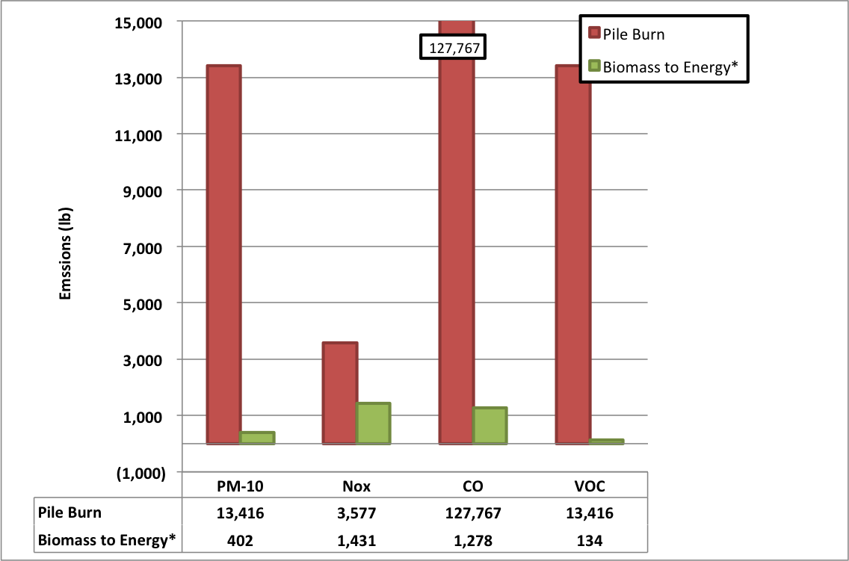

*Emission reductions projections based on scaled model of current emissions of APL’s PP 25kW EU Power Pallet platform.

**Project Emissions Reductions Estimates[6]**

|  |  |  |  |  |
| --- | --- | --- | --- | --- |
| **Criteria** | **PM-10** | **NOx** | **CO** | **VOC** |
| **Reduction (lbs)** | 13,103 | 2,146 | 126,489 | 13,281 |

Estimated air pollutants (g/kWh) based on analysis of APL’s Power Pallet Emissions. APL expects to make significant improvements on these emissions, utilizing catalysts and centrifugal filtration, to meet ARB standards.

**Air Pollutants (g/kWh) - Estimated**

|  |  |  |  |  |  |  |
| --- | --- | --- | --- | --- | --- | --- |
| **Criteria** | **PM10** | **PM 2.5** | **NOx** | **SOx** | **VOCs** | **CO** |
| **(gram/kWh)** | 0.00025[7] | No Data | 1.63[8] | 0.0135[9] | 10.0[10] | 84.5[11] |

**Particulate and Aromatic Hydrocarbon Emissions from a Small-Scale Biomass Gasifier−Generator System, Jaimie E. Hamilton, Energy & Fuels (10 kW Power Pallet)

*** Based on APL’s measurement utilizing Testo 350 Continuous Air Monitoring

The project is estimated to replace 788,400kWh of grid electricity on an annual basis. Assuming 281.8 g CO2e/kWh, the project would save 222,171kG of Carbon Emission/year. See below table for detail of other gasses.

**GHG Pollutant Reductions**

|  |  |
| --- | --- |
| **Pollutant** | **Amount Reduction (kg)** |
| **C02** | **222,171[12]** |
| **Methane** | **7,935[13]** |
| **Nitrous** | **868[14]** |

**Impacted Market Segments:**

It is anticipated that there is significant opportunity for commercial, industrial, and utility scale applications to take advantage of the several unique value propositions of this technology. As part of this project, the deployment rates, scale of potential market, and impacts at various market penetration rates will be analyzed by grant partners, to quantify potential scaling impacts.

By creating a market for forest fire thinning material, this project will enable a significant expansion of current forest thinning practice, thereby lowering the risk of catastrophic wildfire. The resultant rural area employment will create much-needed jobs in economically depressed areas of the state. It can also provide policy makers with a clear example of modular, on demand energy could provide new ways to address grid constraints.

According to estimates from the California Biomass Collaborative in 2007[15] the gross resource available from forestry is 27,000,000 bone dry tons per year, and the technically available resources is 14,000,000 bone dry tons per year. The projected gross electrical potential from forestry is 3,500MW electric.

Each fully commercial Power Pallet consumes 1.2kg of woody biomass per kWh of energy production. At 85% capacity factor for a full year, this equals 246 tons of woody biomass. For a 150kW Powertainer at equal consumption and capacity factor, this would equal 1,476 tons per unit per year.

Assuming a 10% market penetration to available resource, there would be enough biomass available for 9,485 Powertainers in California.

Finally, all of this will work to speed achievement of the State of California’s statutory energy goals, by working to reduce greenhouse gas emissions (AB32 2006), improve air quality, increase the share of in state renewable energy (SB X1-2, 2011-2012), increase the use of bio based energy (Bioenergy Action Plan 2012), and reduce the risk of catastrophic wildfire. As all of the products are assembled in California from locally sourced materials, the project will also support the Governor’s Clean Energy Jobs Plan (2011).

**Cost-to-benefit analysis:**

APL utilized the *Small-Scale Bioenergy LCOE* model prepared for the CPUC as a part of the SB 1122 (Bioenergy Feed-in Tariff) proceeding to determine the project’s estimated LCOE. The resultant analysis shows an LCOE identical to the 2014 REMAT price of $124/MW.

**List of inputs utilizing B&V *Small-Scale Bioenergy* LCOE Calculator**[16]**:**

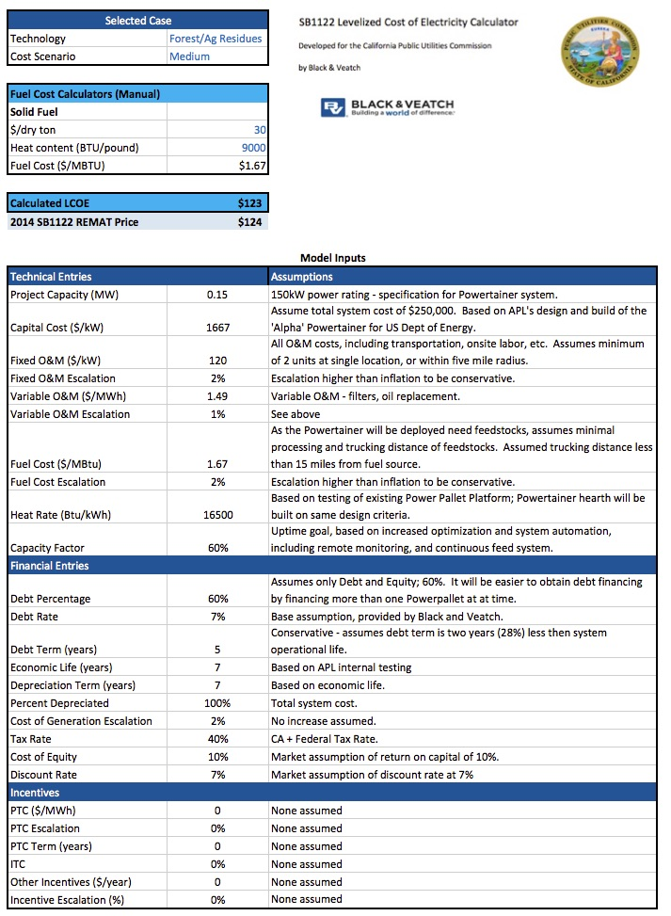

**Summary of Model Inputs:**

$1667/KW of upfront cost are noted in the table above ($250,000 projected final commercial price for a 150kW Powertainer system). No overnight costs are assumed as the platforms are modular and will not be permanently installed. The above calculation assumes no tax credits, subsidies, or market support mechanisms. Installation (non-construction) costs include interconnection, permitting, and site preparation.

APL estimates the final Powertainer will have a useful life of at least seven years. This is based on ‘Alpha’ Powertainer unit, as well as similarly designed Power Pallet platforms around the world. Equipment requiring replacement during lifetime is included in the fixed, annual O&M number in the table above.

The modeling envisions the project as a modular, mobile platform that is co-located in areas with high fuel demand. Therefore, there are no decommissioning costs for the system. Transportation costs are incorporated into the fixed O&M $/KW.

The project will net meter electricity, behind the customer meter at the Placer County Water Facility mixed use industrial and commercial facility, which has significant load. The project is expected to offset peak electrical rates on a PG&E A-6 Rate schedule. The average avoided cost from the A-6 Rate is $0.2308/kWh. (Note that the project is estimated to be economic at the base SB 1122 PG&E REMAT biomass rate of of $124/kWh.) The project would not generate a sufficient return on equity selling electricity at the wholesale price of $50k/MWh.

The project assumes no revenue for waste disposal; rather that the project pays for the processing and transportation of feedstock. See above table for cost assumptions. There may be additional value from selling the biochar that is produced as part of the process. However, no credit is given for the biochar in the financial model.

The project is projected to significantly reduce GHG emissions. Since it will be using as feedstock material that would otherwise be burned, it is likely that we will achieve the same levels of emissions as reflected in the Placer County Air Quality Control District data above.

The project is estimated to replace 788,400kWh of grid electricity. Assuming 281.8 g CO2e/kWh, the project would save 222,171kG of C02 equivalent Emission/year (281.8G * 150kW *60% Capacity Factor * 8760 Hours).

Due to the project’s small scale, it does not anticipate registering with WREGIS to receive RECs.

The UC Berkeley Center for Forestry will work with RAEL and APL to evaluate the aggregate benefits and costs of the technology to California IOU ratepayers through commercialization. Their analysis and reports will include:

* Estimate the maximum size of the potential market for the technology in California, including competition from other technologies
* Establish available biomass/forest resources (fuel)
* Establish water savings and hydrologic impacts
* Evaluate the net benefits of the technology if it were to achieve 1%, 10%, and 100% market penetrations. This analysis will include a cost-benefit analysis of the net benefits, tempering expectation based on competition, financing barriers, and market conditions.

**Potential and rationale for replication of this project in other California locations:**

Rural Placer County has many similar characteristics for conditions statewide regarding forest fire remediation efforts, and thus the potential to reproduce the benefits generated by this project all along the Sierra Nevada range.

Therefore it is reasonable to conclude that roughly analogous avoided emissions, grid stability enhancements, renewable energy creation, improved fire remediation economics/employment and concomitant increase in forest hydrological resource would apply in many of the forested regions of the state.

According to estimates from the California Biomass Collaborative in 2007[17] the technically available resources is 14,000,000 bone dry tons per year, enough for approximately 9,500 Powertainers.

By facilitating the creation and market testing of this technology, California will enable a significant increase in the economic and material well being of forest/urban interface areas statewide.

1. **Team Qualifications, Capabilities and Resources**

**Organizational structure:**

All Power Labs is a Berkeley, CA based company with over 45 employees, focused exclusively on the design, engineering, and manufacture of small scale biomass gasification devices. Project team will include existing engineering and fabrication departments, with support from administration. APL is lead by CEO Jim Mason, who holds several patents for his work in this field.   
  
Key project team members include:

* **Project Manager & Principal Investigator:** Jim Mason, All Power Labs
* **Partner, Data Analysis Lead:** Dan Kammen, Daniel Sanchez, Renewable and Appropriate Energy Lab, UC Berkeley
* **Partner, Data Analysis Lead:** Peter Tittman, Center for Forestry, UC Berkeley
* **Partner; Air Emissions Lead:** Bruce Springsteen, Placer County Air Pollution Control District

**Project Organizational Chart**

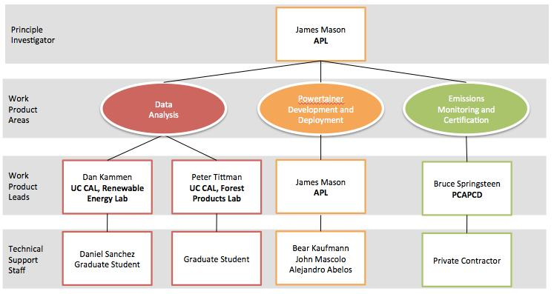

This team represents an strong collaboration between leaders in their respective fields:

* All Power Labs is one of the world’s leading designers of innovative, affordable gasification technology.
* The Placer County Air Quality Control District has long been one of California’s leading voices on the impact of controlled burns as fire remediation with regard to air quality, and the need to use biomass for energy.
* RAEL at UC, Berkeley, lead by Professor Dan Kammen, is recognized as one of the world’s leading experts in emerging renewable energy technology.
* The Center for Forestry at UC, Berkeley, has a well proven track record of providing insightful analysis of California’s forest products industry.
* Sierra Pacific Industries is one of the largest commercial timber companies in the US.

**Explain how the various tasks will be managed and coordinated, and how the project manager’s technical expertise will support the effective management and coordination of all projects in the application.**

In order to meet the design/fabrication/testing schedule for this project, APL will divide their engineering team into working groups to take on the various components, covering: gasifier, filtration, fuel handling, automation, etc.

Following scoping meetings and outlining of tasks, each working group will operate independently while meeting weekly to review progress and areas of concern. Regular meetings will take place between APL and partners to developing timelines and milestones and deliverables.

Once APL feels it has clear line of sight on a schedule for field deployment, SPI and PCAPCD will be notified and mobilized for their respective roles.

APL has used the process outlined above successfully to design all six previous versions of gasification platforms since 2008. Each of those efforts has been lead by Mason. Director of Product Design, Johnny Mascolo, will ensure strict adherence to product development schedule and design intent.

**Facilities, infrastructure, and resources available to team:**

APL’s work will be based in a 22,000 square foot facility in West Berkeley containing all resources for design, engineering, and manufacture, including CAD modeling/cutting tables, laser seam welding bays, and advanced air quality testing materials.

Since APL’s internal engineering/fabrication teams will manage design and construction tasks, very little if any work products will need to be outsourced, ensuring prioritization. Because all aspects of the project-from CAD modeling to laser seam welding to bench and pilot testing--are located in house, APL can rapid cycle the design, manufacturing, and optimization cycle. Existing staff will be supplemented by additional capacity as needed.

On the fuel handling side, Sierra Pacific Industries, a subcontractor for the project, owns all the requisite drum chippers, feeders, trucks and material sorting and processing resources to turn log landings into fuel.

**Team’s history of successfully creating projects and commercializing products:**

This project will build on APL’s extensive expertise in this specialized field. APL has built more gasifiers than any company since World War II. Beginning with the Gasifier Experimenters Kit (GEK) in 2008, APL has churned out six full product revisions or lines since, each advancing the known science and technology of low cost, zero water gasification.

This rapid cycle innovation has attracted partners seeking a “can do” capacity. For example, in order to fulfill a US Department of Energy grant, in just six months in 2012, APL designed, engineered, built and then proved functionality of a 100kW demo “Powertainer” for the University of Minnesota, in partnership with Cummings Engines. This 100kW power plant housed entirely in a 20’ shipping container, produced on demand energy from corn cobs.

The Version 5 Power Pallet was released in January 2014. It was immediately deployed to Kakata, Liberia, as part of a USAID project. Although funding for that project has run out, and the Ebola crisis has crippled much commercial activity, those three units are continuing to perform, and the project is now being expanded to a nearby community to offer reliable power at ½ the cost of currently available diesel power.

The most current recent engineering project for APL, the Power Cube PP25 EU, was released in October 2014. It is a 25kW CE-certified super low emission unit designed to operate in Italy under a Feed-In-Tariff program. Orders have already been received for the entire production capacity of 40 units through the end of February 2015.

With more than 600 units built, and deployed to more than 40 countries, APL are currently managing commercial projects providing on demand renewable energy in many far flung locations, including Liberia, Haiti, and northern Uganda.

*See additional information in Attachment 5 - Project Team Form.*

**Provide current references:**

*See letters in Attachment 9, Reference and Work Product*

1. Design, construction, testing of 100kW Powertainer project, University of Minnesota, Morris, in conjunction with Cummins Engines and the US Department of Energy. See attached letter from Emissions Technician, Dr. James C Barbour.
2. Multiple Unit installation, USAID Liberia Energy Support Sector Project, Kakata, Liberia. See attached letter from Chief of Party Michael McGovern.
3. Technical Equipment provided to BioDico under PIR-11-030.

**Identify any collaboration with utilities, industries, or others. Explain the nature of the collaboration and what each collaborator will contribute.**

APL will collaborate with the following on this project:

* Placer County Water Agency for providing the pilot test site and point of interconnection (see attached commitment letter)
* Sierra Pacific Industries, as a subcontractor, to supply and process biomass fuel (see attached commitment letter)
* Placer County Air Pollution Control District, for emissions testing, certification, and CEAQ application processing. (see attached commitment letter)

**Questions about the legal status of the institution:**

o Has your organization been involved in a lawsuit or government investigation within the past five years? No

o Does your organization have overdue taxes? No

o Has your organization ever filed for or does it plan to file for bankruptcy? No

o Has any party that entered into an agreement with your organization terminated it, and if so for what reason? No

o For Energy Commission agreements listed in the application that were executed (i.e., approved at a Commission business meeting and signed by both parties) within the past five years, has your organization ever failed to provide a final report by the due date indicated in the agreement? No

**Commitment letters (for match funding, test sites, or project partners)*.****See Attachment 11 Commitment Letter*

1. **Budget and Cost Effectiveness**

The funds requested correspond to current labor rates at APL, and/or appropriate rates for student researchers and public institutions. APL is a lean startup company, able to innovate quickly and cost effectively. By housing all aspects of design-to-manufacturing in one facility, rapid cycle innovation and production can take place in a low cost environment. (As an aside, it should be noted here that APL CEO Jim Mason works for no salary).

APL has built six class versions of gasifiers since inception. The tasks hours required, and the private sector cost basis for them, is derived from more that six years at market producing commercial gasification systems.

APL will pay the entire overhead for the project out of pocket as part of their cost share. All of the funds supplied by the CEC will go directly to equipment and staff working directly on the project.

Similarly, all subcontractors/partners have extensive experience performing the exact tasks described, and are basing their projected costs on their experience.

EPIC funding for this project will enable APL to sufficiently mitigate project cost risk as to enable the successful design, engineering, and manufacture of a low-cost modular biomass gasification platform.

1. **Funds Spent in California**

APL expects at least 89.63% of the funds will be spent in California on direct labor, minor subcontracts, and in state travel (no airline tickets). The remaining 10.37% will be spent on some overhead for the University of California, Berkeley Center For Forestry, and Equipment and Materials - all of which where possible will be sourced from California vendors.

Additional information can be found in *Tab B-2 of Attachment 7, Budget Forms.*

1. **Ratio of Unloaded Labor Rates to Loaded Labor Rates**

APL is matching funding for all G&A, as well as Indirect Overhead for the APL portion of the project. The University of California, Berkeley – Forest Products Lab budgets for some Indirect Overhead ($66,435). The Average Team score on Tab B-7 of Attachment 7, Budget Forms, is 0.894; the Team Score is 4.471.

1. **Match Funding**:

All Power Labs has committed to contribute $476,250 in cash, of the $2,466,321 total budget of the project.

*See attached letter from All Power Labs in Section 11 Commitment Letters.*

1. Presentation: Augmenting Water Supply From Forests, Prepared for the East Bay Municipal Utility District by Nick Wobbrock of the Nature Conservancy, 8/11/2014
2. Assumes 60% capacity factor for year 1 of operation, 150kW system size [150kW * 8760hr * 60% Capacity Factor) = 788,400kWh)
3. The peak rating of the Powertainer system; assumes the Powertainer will be operational during times of peak demand, delivering net metered electricity to the host, reducing the host site electrical demand or feeding the energy back to the grid for consumption.
4. Assumes 788,400kWh sold at $124/MWh; SB1122 1014 REMAT Price
5. Compared to the average water requirements of a new, GE LM6000 natural gas thermal generator. [50,000kW = 72.7gal/min]. Scaled to 150kW [0.003 (72.7(GPM) * 150/50,0000 (kW to scale) * 525,600 (8760 hours * 60min) * 60% (capacity factor) = 68,780 gallons].
6. Presentation: Placer County Forest Resources Sustainability Initiatives, Tom Christofk, Placer County Air Pollution Control District, 11/14/2012
7. Particulate and Aromatic Hydrocarbon Emissions from a Small-Scale Biomass Gasifier−Generator System, Jaimie E. Hamilton, Energy & Fuels (10 kW Power Pallet)
8. Based on APL’s measurement utilizing Testo 350 Continuous Air Monitoring Equipment
9. Based on APL’s measurement utilizing Testo 350 Continuous Air Monitoring Equipment
10. Particulate and Aromatic Hydrocarbon Emissions from a Small-Scale Biomass Gasifier−Generator System, Jaimie E. Hamilton, Energy & Fuels (10 kW Power Pallet)
11. Based on APL’s measurement utilizing Testo 350 Continuous Air Monitoring Equipment
12. (281.8G * 150kW *60% Capacity Factor * 8760 Hours)/1000
13. (281.8G * 150kW *60% Capacity Factor * 8760 Hours)/1000/ 28GWP Value
14. (281.8G * 150kW *60% Capacity Factor * 8760 Hours)/1000/ 265 GWP Value
15. http://128.120.151.3/biomass/files/2013/09/09-20-2013-An-Assessment-of-Biomass.pdf
16. Inputs to SB1122 Levelized Cost of Electricity Calculator developed by Black & Veatch.
17. http://128.120.151.3/biomass/files/2013/09/09-20-2013-An-Assessment-of-Biomass.pdf